**Lab 2 (Packet Tracer – Creating a LAN Topology)**

Learning outcomes

Learn how to use packet tracer

Create multiple nodes or devices in the network

Interconnect all devices together

Ping various devices in the network to ensure connectivity

To perform the lab exercise, first, you need to download Cisco Packet Tracer. Once it is downloaded, install it using the default selections. After the installation, you can create a network topology to perform the hands-on lab exercise.

**Packet Tracer – Creating a New Topology**

**What is Packet Tracer?**  Packet Tracer is a protocol simulator developed by Dennis Frezzo and his team at Cisco Systems. Packet Tracer (PT) is a powerful and dynamic tool that displays the various protocols used in networking, in either Real Time or Simulation mode. This includes layer 2 protocols such as Ethernet and PPP, layer 3 protocols such as IP, ICMP, and ARP, and layer 4 protocols such as TCP and UDP. Routing protocols can also be traced.

**Purpose**: The purpose of this lab is to become familiar with building topologies in Packet Tracer.

**Requisite knowledge**: This lab assumes some understanding of the Ethernet protocol. At this point we have not discussed other protocols, but will use Packet Tracer in later labs to discuss those as well.

**Version**: This lab is based on Packet Tracer 5.0.

**Step 1: Start Packet Tracer**

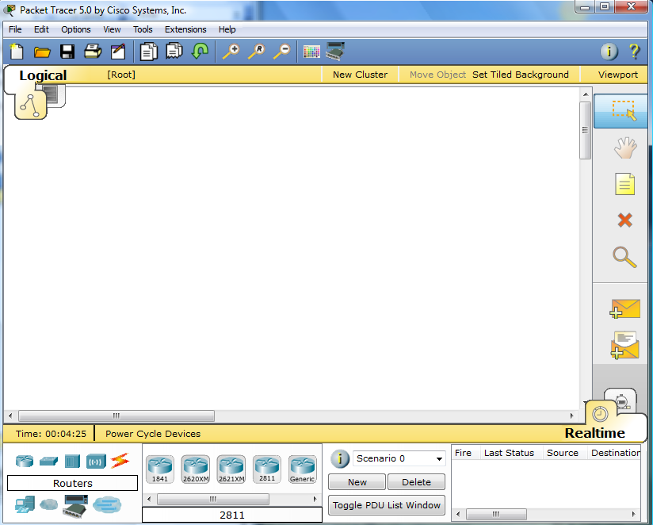

**Step 2: Choosing Devices and Connections**

We will begin building our network topology by selecting devices and the media in which to connect them. Several types of devices and network connections can be used. For this lab we will keep it simple by using **End Devices**, **Switches**, **Hubs**, and **Connections**.

Single click on each group of devices and connections to display the various choices. The devices you see may differ slightly.

|  |  |
| --- | --- |
|  |  |
|  |  |
|  | |
|  |  |
|  |  |

**Step 3: Building the Topology – Adding Hosts**

Single click on the **End Devices**.

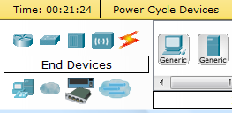

Single click on the **Generic** host.



Move the cursor into topology area. You will notice it turns into a plus “+” sign.

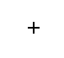

Single click in the topology area and it copies the device.

|  |  |
| --- | --- |
|  |  |

Add three more hosts.

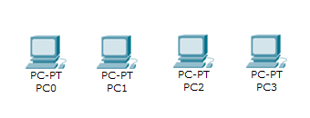

**Step 4: Building the Topology – Connecting the Hosts to Hubs and Switches**

**Adding a Hub**

Select a hub, by clicking once on **Hubs** and once on a **Generic** hub.

|  |  |  |
| --- | --- | --- |
|  |  |  |

Add the hub by moving the plus sign “**+**” below PC0 and PC1 and click once.

|  |  |
| --- | --- |
|  |  |

Connect PC0 to Hub0 by first choosing **Connections.**

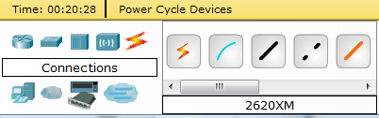

Click once on the **Copper Straight-through** cable.

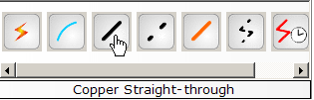

Perform the following steps to connect **PC0** to **Hub0**:

1. Click once on **PC0**
2. Choose **FastEthernet**
3. Drag the cursor to **Hub0**
4. Click once on **Hub0** and choose **Port 0**
5. Notice the green link lights on both the **PC0** Ethernet NIC and the **Hub0** Port 0 showing that the link is active.

|  |  |  |  |  |
| --- | --- | --- | --- | --- |
| **1** | **2** | **3** | **4** | **5** |
|  |  |  |  |  |

Repeat the steps above for **PC1** connecting it to **Port 1** on **Hub0**. (The actual hub port you choose does not matter.)

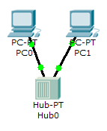

**Adding a Switch**

Select a switch, by clicking once on **Switches** and once on a **2950-24** switch.

|  |  |  |
| --- | --- | --- |
|  |  |  |

Add the switch by moving the plus sign “**+**” below PC2 and PC3 and click once.

|  |  |
| --- | --- |
|  |  |

Connect PC2 to Hub0 by first choosing **Connections.**



Click once on the **Copper Straight-through** cable.



Perform the following steps to connect **PC2** to **Switch0**:

1. Click once on **PC2**
2. Choose **FastEthernet**
3. Drag the cursor to **Switch0**
4. Click once on **Switch0** and choose **FastEthernet0/1**
5. Notice the green link lights on **PC2** Ethernet NIC and amber light **Switch0** **FastEthernet0/1 port**. The switch port is temporarily not forwarding frames, while it goes through the stages for the Spanning Tree Protocol (STP) process.
6. After a about 30 seconds the amber light will change to green indicating that the port has entered the forwarding stage. Frames can now forwarded out the switch port.

Note: Spanning Tree Protocol (STP) is discussed later.

|  |  |  |  |  |  |
| --- | --- | --- | --- | --- | --- |
| **1** | **2** | **3** | **4** | **5** | **6** |
|  |  |  |  |  |  |

Repeat the steps above for **PC3** connecting it to **Port 3** on **Switch0** on port **FastEtherent0/2**. (The actual switch port you choose does not matter.)

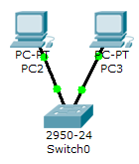

Move the cursor over the link light to view the port number. **Fa** means FastEthernet, 100 Mbps Ethernet.

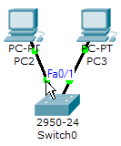

**Step 5: Configuring IP Addresses and Subnet Masks on the Hosts**

Before we can communicate between the hosts we need to configure IP Addresses and Subnet Masks on the devices.

Click once on PC0.

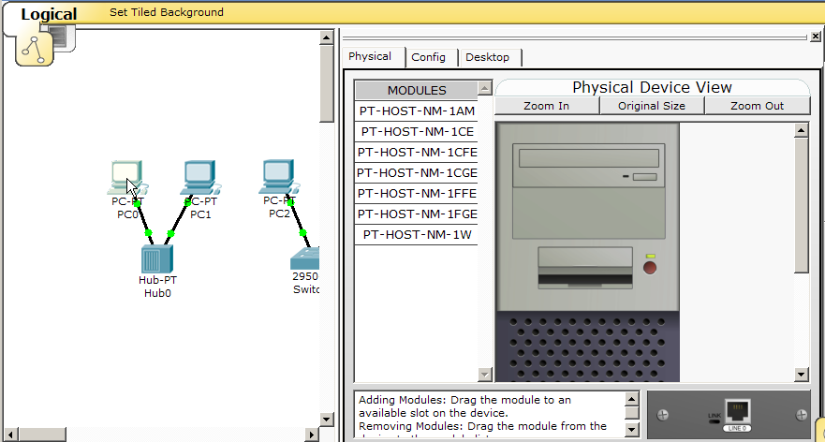

Choose the **Config** tab and click on **Settings**. It is here that you can change the name of PC0. It is also here where you would enter a **Gateway** IP Address, also known as the default gateway and the **DNS Server** IP Address. We will discuss this later, but this would be the IP address of the local router. If you want, you can enter the Gateway IP Address 172.16.1.1 and DNS Server IP Address 172.16.1.100, although it will not be used in this lab.

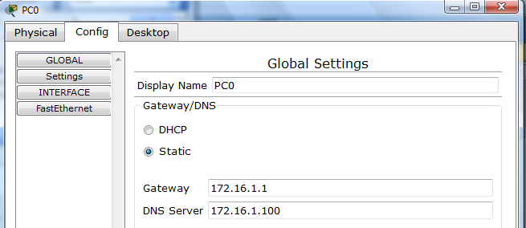

Click on **Interface** and then **FastEthernet**. Although we have not yet discussed IP Addresses, add the IP Address to 172.16.1.10. Click once in the Subnet Mask field to enter the default Subnet Mask. You can leave this at 255.255.0.0. We will discuss this later.

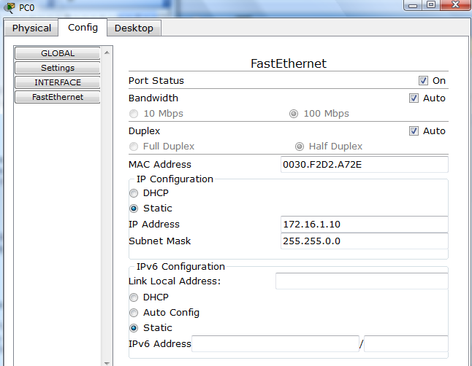

The information is automatically saved when entered.

To close this dialog box, click the “**X**” in the upper right.



Repeat these steps for the other hosts. Use the information below for IP Addresses and Subnet Masks.

|  |  |  |
| --- | --- | --- |
| **Host** | **IP Address** | **Subnet Mask** |
| PC0 | 172.16.1.10 | 255.255.0.0 |
| PC1 | 172.16.1.11 | 255.255.0.0 |
| PC2 | 172.16.1.12 | 255.255.0.0 |
| PC3 | 172.16.1.13 | 255.255.0.0 |

**Verify the information**

To verify the information that you entered, move the Select tool (arrow) over each host.

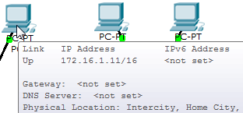

**Deleting a Device or Link**

To delete a device or link, choose the **Delete** tool and click on the item you wish to delete.

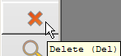

**Step 6: Connecting Hub0 to Switch0**

To connect like-devices, like a Hub and a Switch, we will use a Cross-over cable. Click once the **Cross-over** Cable from the **Connections** options.

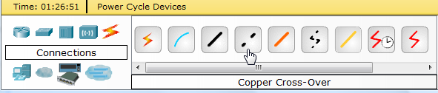

Move the Connections cursor over **Hub0** and click once.

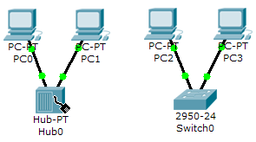

Select **Port 5** (actual port does not matter).

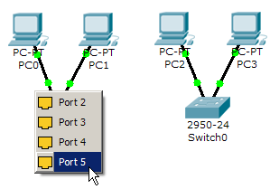

Move the Connections cursor to **Switch0**.

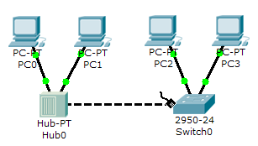

Click once on **Switch0** and choose **FastEthernet0/4** (actual port does not matter).

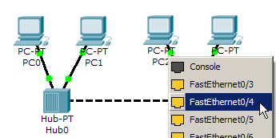

The link light for switch port **FastEthernet0/4** will begin as amber and eventually change to green as the Spanning Tree Protocol transitions the port to forwarding.

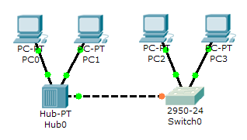

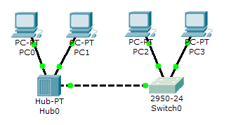

**Step 7: Verifying Connectivity in Realtime Mode**

Be sure you are in **Realtime** mode.

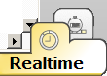

Select the **Add Simple PDU** tool used to ping devices..



Click once on PC0, then once on PC3.

|  |  |
| --- | --- |
|  |  |

The PDU **Last Status** should show as **Successful**.

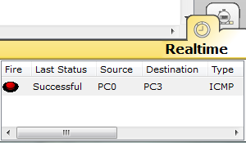

**Resetting the Network**

At this point we will want to reset the network, Whenever you want to reset the network and begin the simulation again, perform the following tasks:

Click **Delete** in the PDU area.

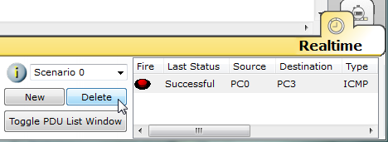

Now, Power Cycle Devices and confirm the action.

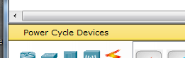

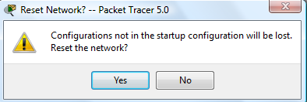

**Waiting for Spanning Tree Protocol (STP)**

**Note**: Because Packet Tracer also simulates the Spanning Tree Protocol (later), at times the switch may show amber lights on its interfaces. You will need to wait for the lights to turn green on the switches before they will forward any Ethernet frames.

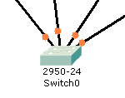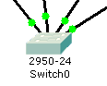

**Step 8: Verifying Connectivity in Simulation Mode**

Be sure you are in **Simulation** mode.

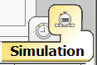

Deselect all filters (All/None) and select only **ICMP**.

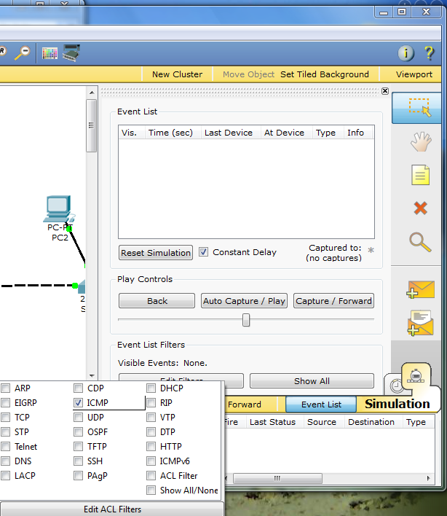

**3**

**2**

**1**

Select the **Add Simple PDU** tool used to ping devices..



Click once on PC0, then once on PC3.

|  |  |
| --- | --- |
|  |  |

Continue clicking **Capture/Forward** button until the ICMP ping is completed. You should see the ICMP messages move between the hosts, hub and switch. The PDU **Last Status** should show as **Successful**. Click on **Clear Event List** if you do not want to look at the events or click **Preview Previous Events** if you do. For this exercise it does not matter.

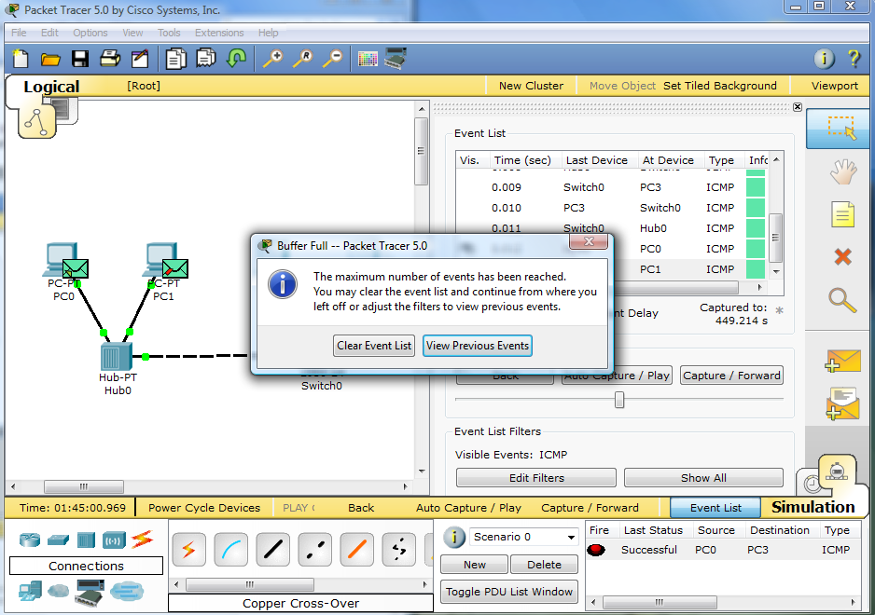

**Step 9: Saving the Topology**

Perform the following steps to save the topology (uses .pkt file extension).

|  |  |
| --- | --- |
|  |  |

**Opening Existing Topologies**

|  |  |  |
| --- | --- | --- |
|  |  |  |

**Opening Existing PT Topologies**

|  |  |  |
| --- | --- | --- |
|  |  |  |
|  |  |  |

Lab Exercise 2